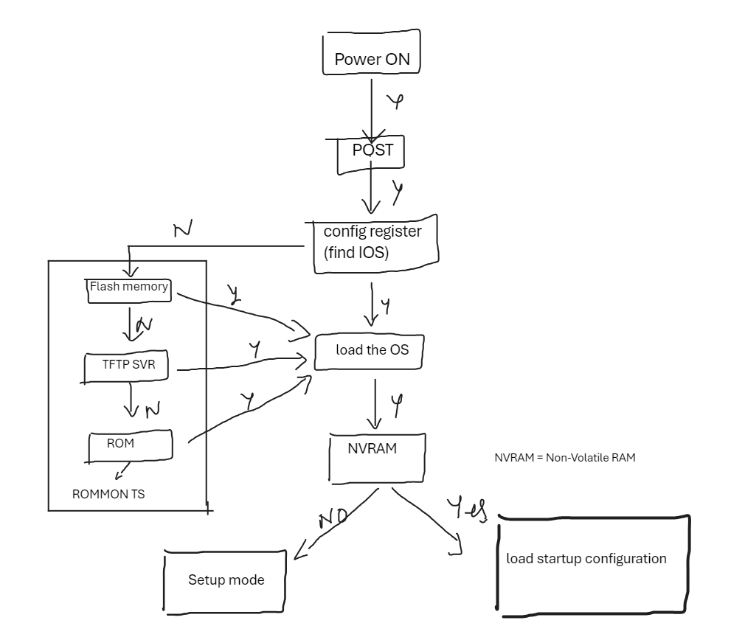

1. Router is powered on.
2. It performs POST (power on self-test).
   1. It checks all the hardware, CPU, memory, etc.
3. Bootstrap program is loaded & executed (whenever IOS is found, load it)
4. Bootstrap reads configuration register values & loads the IOS.
5. If bootstrap fails, it will drop boot sequence & then move it to the ROMMON troubleshooting program.
6. If the IOS is loaded, it will try to load the config file.
7. Once the configuration is loaded then CLI interface will be present in front of you.